**"Sensor Board X-NUCLEO-IKS01A02”**

* + **Purpose of the Lab**
  + **Test the Use Case Plug Sensor Board with Starter Package**
  + **Understand the Use Case Plug Sensor board**

**Color convention**

***Blue rectangle: commands on Linux Host***

***Open Linux Terminal Window and copy/paste Linux Host command lines:***

|  |
| --- |
| ***Linux host command lines*** |

***Pink rectangle: commands on the board***

***Open Hyperterminal with following command line from Linux host***

|  |
| --- |
| ***minicom –D /dev/ttyACM0*** |

***Then copy/paste board command lines in Hyperterminal:***

|  |
| --- |
| ***Board command lines*** |

 You may need following copy after copy from linux host to board to force real copy

|  |
| --- |
| ***sync*** |

**Wiki user guide reference**

<https://wiki.st.com/stm32mpu/wiki/How_to_integrate_the_IKS01A2_expansion_board_with_STM32MP157C-DK2>

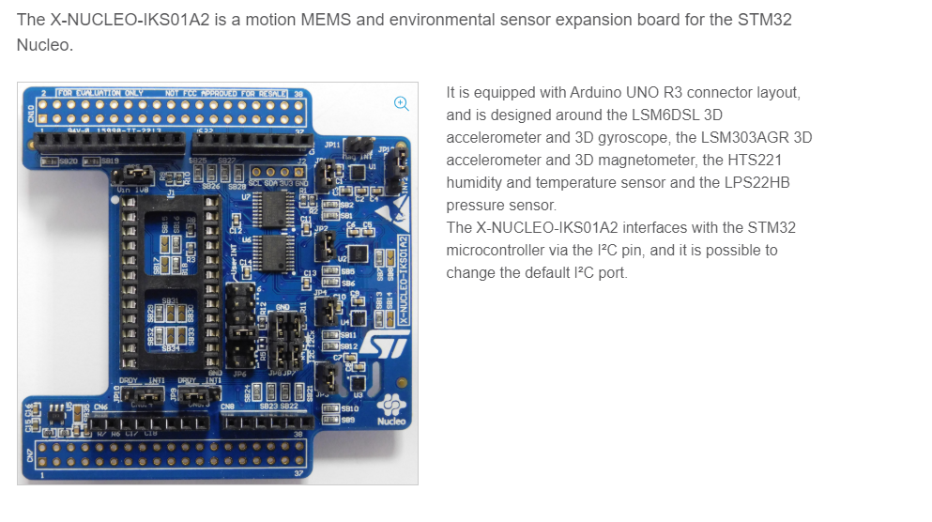

* + **STM32MP1 Starter Package: Test the Use Case Plug Sensor board**
  + **Add dtb configuration in boot for** iks01a2

Observe difference in configuration:

|  |
| --- |
| ***diff stm32mp157c-dk2.dts.dk2-iks01a2 stm32mp157c-dk2.dts.origin***  ***diff extlinux.conf extlinux.conf.origin*** |

**Copy new dtb and new configuration**

|  |
| --- |
| ***scp*** stm32mp157c-dk2-iks01a2.dtb [root@192.168.7.2:/boot/](mailto:root@192.168.7.2:/boot/)  ***scp extlinux.conf*** [root@192.168.7.2:/boot/mmc0_stm32mp157c-dk2_extlinux](mailto:root@192.168.7.2:/boot/mmc0_stm32mp157c-dk2_extlinux)  scp display_sensor.py root@192.168.7.2:/usr/local |

* + **Execute python script on board**

|  |
| --- |
| ***cd /usr/local***  ***python3 display_sensor.py*** |

* + **STM32MP1 Starter Package: Understand the Use Case Plug Sensor board**

Observations (refer to wiki page)

<http://intranet.lme.st.com:8000/php-bin/mm_wiki/index.php/IKS01a2_with_STM32mp157c-dk2>

|  |
| --- |
| cat /proc/device-tree/soc/i2c\@40015000/status  ls -l /proc/device-tree/soc/i2c\@40015000/  grep OF_NAME /sys/bus/iio/devices/iio\:device*/uevent |

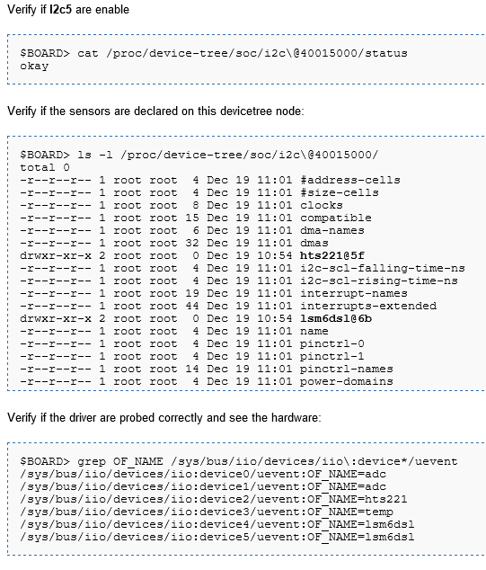

Observations (refer to wiki page)

|  |
| --- |
| grep OF_NAME /sys/bus/iio/devices/iio\:device*/uevent |

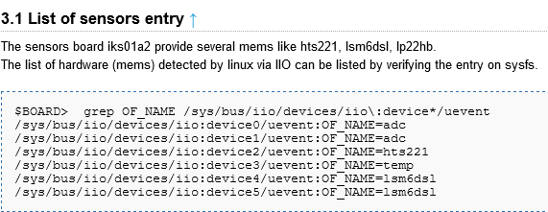

Observations **hts221 Temerature/Humidity** entry are

/sys/bus/iio/devices/iio:device2/ (refer to wiki page)

|  |
| --- |
| cat /sys/bus/iio/devices/iio\:device2/in_temp_raw  cat /sys/bus/iio/devices/iio\:device2/in_temp_offset  cat /sys/bus/iio/devices/iio\:device2/in_temp_scale |

